Chase Cothern
Professor Rhonda Kelley
English 1101 MW 8:00
2 Dec. 2014

College Athletes Should Be Paid
College athletes should indeed be paid. Many of them come from poor families and they need the money. A scholarship only helps them out with some of their college financial needs. They may also feel the need to help their families back home. These athletes have to miss important classes for nationally televised games that bring in a lot of revenue. Currently the NCAA produces nearly eleven billion in annual revenue from college sports. Many popular college athletes have gotten into trouble for accepting money offered to them when they probably really needed it. Every time these athletes compete in any sport they risk having a career ending injury, so I believe they should at least get a small portion of the money.

There are many college athletes that come from families that can hardly afford to put food on the table. How could someone be expected to turn down money offered to them when their family is in such need? At the same time these athletes who accept the money and get caught are frowned upon and punished for breaking NCAA rules. This is just not right. It seems like some kind of financial support could be put in place if their families have very low income or no income. NCAA president Mike Emmert tells us “Rather than push college athletes further and further from academics, we need to bring it closer.” Giving money to college athletes is not pushing them away from academics. It seems like he is being selfish to me, and he only wants more money for himself. Not all college athletes need extra money, but the ones that do have families that are struggling back home. The NCAA is capable of putting a system in place where financial aid goes to the athletes who need it. If anything this might encourage them to do better in academics because they will be able to focus in school more instead of worrying about their loved ones back home. Also, they are getting paid while in college. That is why football and basketball players want to get drafted as soon as possible. They want to support themselves and their families back home.
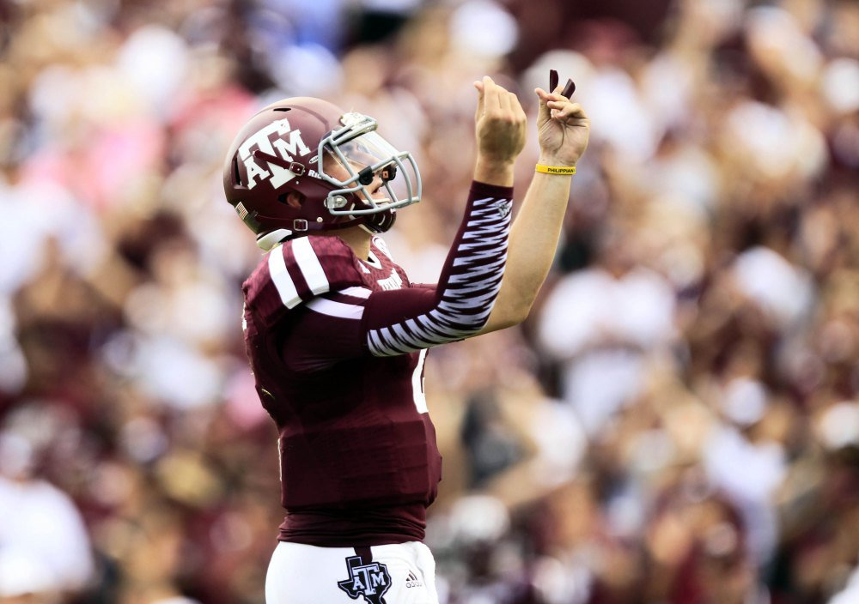
The NCAA makes almost eleven billion dollars every year from college sports. Edelman also tells us that a lot of this money does not go back in the classroom. In my opinion, a few people are getting a large portion of this money. What would it hurt to give college athletes who need it a small amount of this revenue? They have more than enough money to provide for athletes. It is a matter of them wanting to do it. Chris Smith wrote, CBS and Turner Broadcasting make more than one billion off the men’s NCAA basketball tournament “March Madness”. The players do not see any of this money though. If it were not for them, none of this would be possible, but yet they get nothing from it. More of the money should go to classrooms and some to college athletes. Everyone in the college would benefit from this. The NCAA needs to take a long look at how much money they get from college sports and where this money goes. Maybe they will see that many college athletes have families that are struggling and need some of the money. Out of all the revenue that comes in, surely there is a way to let the athletes have a portion of it.

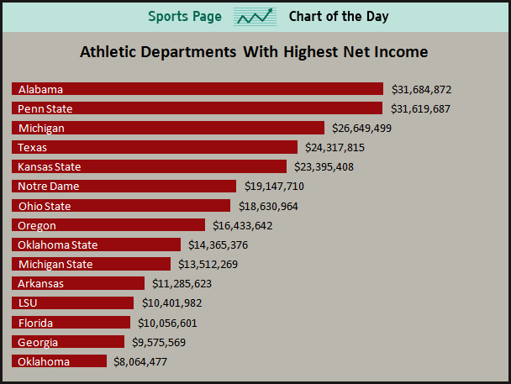

This season Georgia’s star running back, Todd Gurley, was fined for accepting over three thousand dollars for autographs. He had to also miss several games including their game against Florida. The NCAA was quick to suspend Gurley about this. What if his family needed the money back home? He even could have needed clothes or gas money, but the NCAA doesn’t think about this. Georgia tried to get a two game suspension for Gurley, but that just was not long enough for the NCAA. Gurley released this statement accepting that he broke NCAA rules “I want to thank the university, coaches, teammates, and the Bulldog Nation for their patience and support,” he said. “I take full responsibility for the mistakes I made, and I can’t than the university, my coaches, and teammates enough for supporting me throughout this process. I’m looking forward to getting back on the field with my teammates.” Back in 2010, Reggie Bush had to return the replica of the Heisman Trophy for accepting hundreds of thousands of dollars in gifts during his college years at U.S.C. This is ridiculous. At that time he and his family probably had very little money so if someone offered him money, he was more than willing to accept it. “It is wrong that Reggie is the only individual getting punished,” Walker said. “Pete Carroll was in a position of leadership and could have helped Reggie. He gets to leave U.S.C. and take all
that money from Seattle. Are they going to fine Pete Carroll, too?
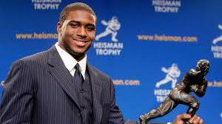

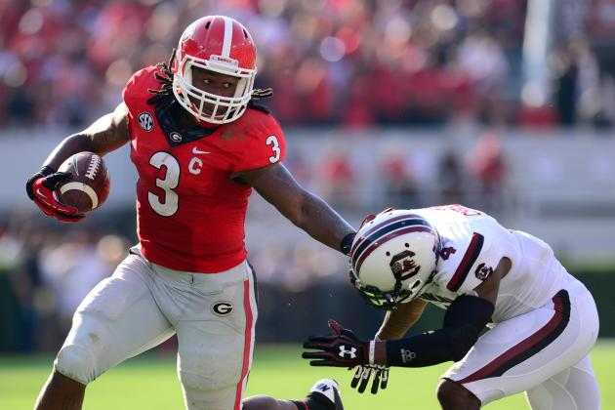

In football and basketball especially, athletes risk a career ending injury every time they compete. It seems like they should be entitled to some of the money that is made from them competing. Take Louisville’s Kevin Ware for example, he broke his leg last year and had to have surgery that will disable him to ever play on the court again. A group of former players have filed an antitrust lawsuit stating that student athletes are entitled to a portion of the money the NCAA brings in off of using their names and likenesses on merchandise such as jerseys and video games. More groups like this need to step up and take action or nothing will change. Student athletes can no longer be considered amateurs when such a big amount of revenue is made off of them competing. They are the ones out on the field or court playing, so they certainly deserve some amount of cash. TV stations and others are not the ones risking their health for entertainment.

Paying college athletes will not take away from academics. Many of them simply need the money because of their financial needs or their struggling families back home. We see student athletes get in trouble for accepting money or gifts time and time again, but is this really a bad thing? Out of eleven billion dollars it seems like there would be enough to give to the college athletes who need it. Most importantly, I think NCAA athletes deserve to get paid.

Works Cited

Campbell, Thomas. 2014. Photograph. Usatoday.com. Web. 8 May 2014
Edleman, Marc. “21 Reasons Why Student Athletes Are Employees And Should Be Allowed To
Unionize.” Forbes.com, 30 Jan 2014. Web.
Gaines, Cork. 2012. Photograph. Businessinsider.com. Web. 3 April 2012.
Newberry, Paul. “NCAA Rules Georgia Star Gurley Mush Sit Until Nov. 15 for Taking Over
$3,000 for Autographs.” Usnews.com, 29 Oct. 2014. Web.
Pennington, Bill. “Reggie Bush, Ineligible for ’05, Returns Heisman.” Nytimes.com, 14 Sept.
2010. Web.
“Should NCAA Athletes Be Paid?” Usnews.com, 1 April 2013. Web.
Zanine, Dale. 2013. Photograph. Bleacherreport.com. Web. 19 Sept. 2013

