**MEASURES OF CENTRAL TENDENCY** [Close](http://faculty.sgc.edu/westwood/Lessons.htm)

A measure of central tendency is intended to go give a measure of where the middle of the data lies.  This depends on what you mean by middle and several measures are used.

**The Mean  (or average)**

The Greek uppercase sigma,   is used to denote a sum.  Summation notation is going to be used a lot, so it is important that you get familiar with it.

Suppose you have data 23, 24, 14, 7, 9, 17.  Then *x* denotes a data value and *x* denotes the sum of the data.

In this case *x* = 23 + 24 + 14 + 7 + 9 + 17 = 96

Click here to read about populations and samples [populations and samples](http://faculty.sgc.edu/westwood/SamplesAndPopulations.htm).

The mean is the sum of all data divided by the number of data.  A sample mean is denoted ** (*x* - bar) and a population mean is denoted **  (Greek lower case mu)*.*

A sample size is denoted *n*, and the population size is denoted *N.* We then have

http://faculty.sgc.edu/westwood/Centra1.gif

Note that some books, including yours, use in place of 

**The Median**

The median is the middle number when a set of data is written in order when there are an odd number of data.

For example for 2, 5, 7, 11, 23, 31, 40, 40, 42 the median is 23

When there are an even number of data the median is the average of the middle two values

For example for 2, 5, 7, 11, 23, 31,  the median is (7 + 11)/2 = 9

**The Mode**

For our purposes the mode is fairly useless.  It is the most frequently appearing data value.

For example for 2, 5, 7, 11, 23, 31, 40, 40, 42 the mode is 40.  [More on the mode](http://faculty.sgc.edu/westwood/MoreOnMode.htm)

**The Midrange**

The midrange is the value half way between the highest and lowest values, or it is the average of those two values.

http://faculty.sgc.edu/westwood/Centra7.gif

**Weighted Means (or weighted averages)**

 Suppose you are judging a science project, the project is to be judged on originality, how well it is put together and how well it works.  However the three items judged do not carry the same weight.  Suppose originality is weighted 5, how well it is put together is weighted 2 and how well it works is weighted 4.



To evaluate this you multiply each score by its weight and then divide by the sum of the weights.  Suppose scores were 9 for originality, 7 for how well it is put together and 3 for how well it works.  Then

                  [Your grade as a weighted mean.](http://faculty.sgc.edu/westwood/Grade.htm)

**Picturing Distributions**

The idea is that area under the curve between two values corresponds to the number of data between the two values. This means that the median should have half of the area to the left and half to the right. Below C is the median. The mode is where you find the greatest number of values, A in this case. The mean is B as explained below.

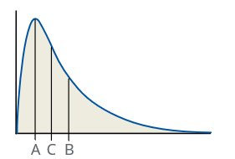

If the data is symmetric as in the picture below then the mean, median and mode are all in the

middle at C.

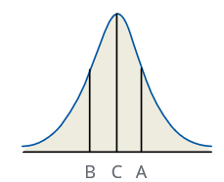

If you take this picture and drag the curve to the right of the median to the right, and leave the region to the left of the median the same, getting something like the first picture, the median will stay the same but overall the values of the data will increase making the mean bigger than the median. Similarly if data is skewed left the mean is less than the median.

In the following picture C is the mode, A is the median and B is the mean.

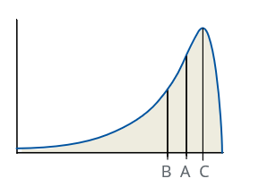

[Close](http://faculty.sgc.edu/westwood/Lessons.htm)