1. Express  on [2, 5] as a definite integral.

8

1

1

∫

2. Evaluate 

3

1

1

∫

3

3. Evaluate 

4. Find the area under the curve over the interval [0, $]$

5



6

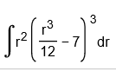

7



8



9



10



11



12.



13.



14.



15.

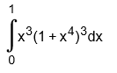

14.

*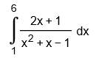*

16

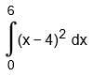

17



18



19



20

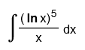

21

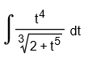

22

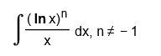

23. Find the average value of  over the interval [−1, 2]