1. Express  on [2, 5] as a definite integral. 

∫

8

1

1

2. Evaluate 

Use . =

3

1

1

∫3

3. Evaluate 

Use . = 



4. Find the area under the curve over the interval [0, $]$



5





6

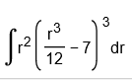



7





8





9





10





11





12.





13.





14.



The 7 is too high to be an exponent. It is intended to be a seventh root.



15.

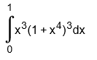



15.

*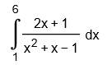*



16.

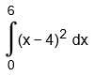

=24

17





18



This one is too evil to put on the test!

19





20

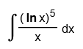



21

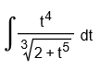



22

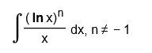



23. Find the average value of  over the interval [−1, 2]

