What you must know for Calculus I Test 4

Definition of indefinite integral:

, where *F* is a function whose derivative w.r.t. *x* is *f* (If such an *F* exists)

Definition of definite integral:

 = , where is a partition of [*a*, *b*]. (If the limit exists, in which case we say *f* is integrable. The limit always exists for continuous functions)

Fundamental Theorem of Calculus:

, where *F* is any antiderivative of *f* (If *f* is continuous on [*a*, *b*])

Properties:

1. 2. 

3. 4.

5. 6.  7. 

Average value = 

Area:

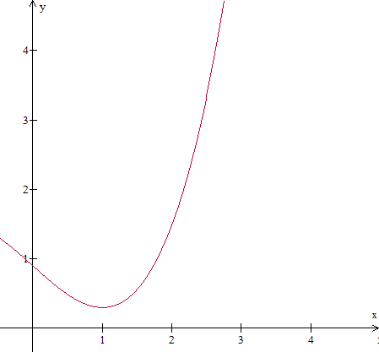



The shaded area = 

*b*

*a*

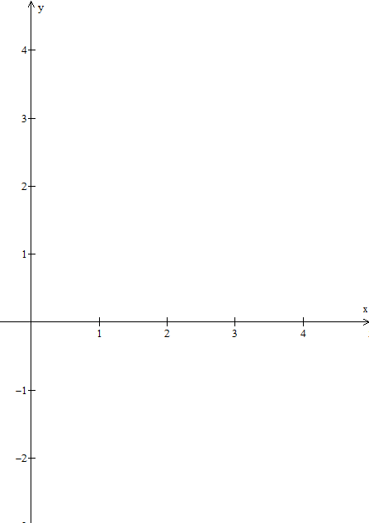





Area = 

Area = 

3 4

*b*

*a*