  - Chapter 8
  - Introduction to Perfect Competition

Market structure

Describes

number of suppliers

product’s degree of uniformity

ease of entry into the market

forms of competition

A firm’s decisions depend on the market structure. They include

how much to produce

what price to charge

1a. Perfectly Competitive Market Structure

Many buyers and sellers

Commodity (standardized/identical product)

Fully informed buyers and sellers (i.e. perfect knowledge of the market price and quality of the product)
- No barriers to entry/exit (i.e. extremely easy to set up/leave the business)
- Individual buyer or seller are price takers (i.e. no one can control over price)

1b. Demand under Perfect Competition

Market price is determined by supply and demand

The demand curve facing one supplier is horizontal at the market price (perfectly elastic)

Short Run Profit Maximization

Maximize economic profit: quantity at which total revenue exceeds total cost by the greatest amount

Review the following concepts:

Total revenue, TR=

Total cost, TC =

Profit =

If TR > TC: economic

If TC > TR: economic

Marginal cost, MC = (changes in TC)/(changes in Q)

New concepts:

Marginal revenue

MR = (changes in total revenue)/(changes in Q)

Example 1.

A farmer produces wheat. The market price of wheat is $15/bushel. Which quantity maximizes profit?

Line 1 | Line 2 | Line 3 | Line 4 | Line 5 | Line 6 | Line 7
Q | P | TR | TC | Profit | MR | MC
0 |  |  | $10 |  | --- | ---
1 |  |  | $20
2 |  |  | $25
3 |  |  | $30
4 |  |  | $40
5 |  |  | $55
6 |  |  | $90

Interesting points:
- Both 4 or 5 maximizes profit. Which one is better? __

- Golden Rule of profit maximization: ___

- P^{e} = MR = demand
The demand curve is ___

- If the farmer is producing at Q = 2, should he produce one more unit? why

If MR >MC, expand Q can increase profit

- If the farmer is currently growing 6 bushel, should he change the quantity? Why?

If MR < MC, reduce Q can increase profit

Economists think at the margin

- Case studies
Review:
- There are three U-shaped cost curves: _____, _____, and _____.
- MC always goes through the __________ point of ATC and AVC
- ATC is always ______ AVC; the vertical distance between the two curves is _____
- In perfect competition market, P = MR = demand for a firm
- The Golden Rule to maximize profit is ___________
- TR = _________
- TC = (ATC)(Q)
- Profit = __________
- Q* = profit maximizing output / optimal output

Case Study 1. How to maximize profit?
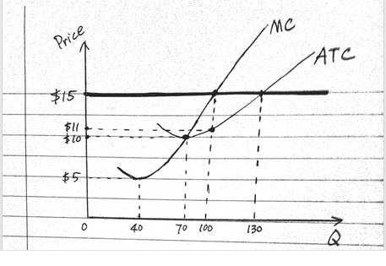 | The graph on the left shows a wheat farmer’s production costs. The market price for wheat is $15/bushel. Which output level should this farmer produce in order to maximize profit?
- What is MR?

- Which output level maximizes profit?

- If this farmer maximizes profit, what is the TR?

- What is TC?

- How much is the maximum profit?

Case Study 2. How is business?
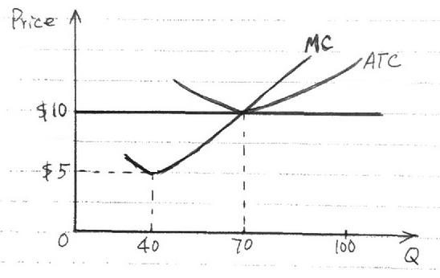 | The figure on the left shows a wheat farmer’s production costs. The market price is $10.
- What is MR?
- What is the demand for this farmer?
- Which output level maximizes profit?
- If this farmer maximizes profit, what is his TR?
- What is TC?
- How much is the maximum profit?
- So how’s business?
- Breaking Even Point
Case Study 3. What’s going on?
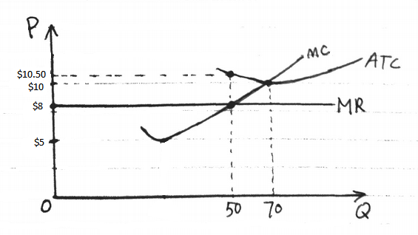 | The figure on the left shows a wheat farmer’s production costs. The market price is $8.
- What is MR?
- What is the demand for this farmer?
- Which output level maximizes profit?
- If this farmer maximizes profit, what is his TR?
- What is TC?
- How much is the maximum profit?
- When a firm incur losses, should it still produce at where MR = MC?

Summary:
 | Total View | Per unit view | Graph view
Economic profit
Breaking even
Economic loss

If a firm loses money, should the firm
- continue to produce (i.e. stay in business)

- close out for a short while (i.e. shutdown), or

- leave the industry permanently (i.e. exit)?

Case Study 4. Stay or shutdown?
Along the coast line in the north, the demand for a small motel room in a cold winter season is very low. The graph on the right shows the cost and demand. Analyze this firm’s situation and give an economic suggestion. | 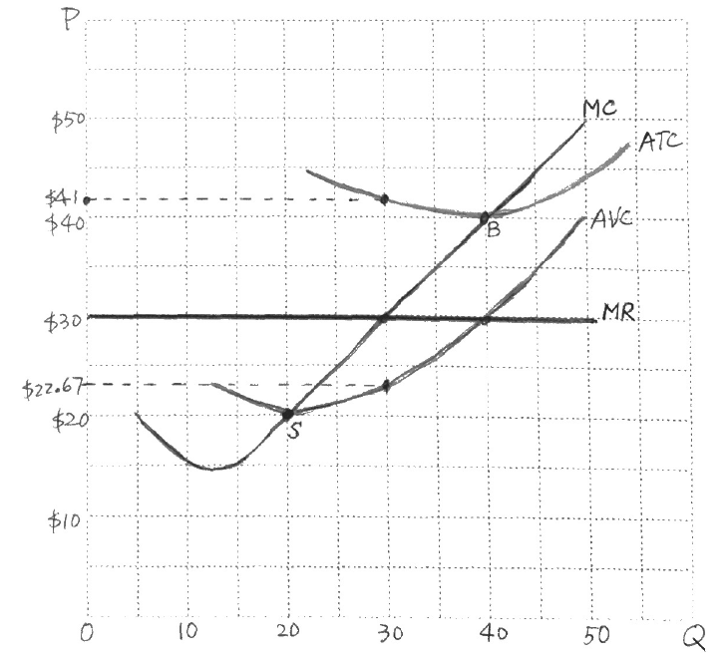
- Market price = _______
- Is this firm making profit, breaking even, or losing money?
- If the firm stays in business, what is the operational loss?
TR =
TC =
Profit =
- What if the firm shuts down during the winter? If it closes out, it still has to pay the fixed cost. What is the firm’s FC?
TC =
VC =
FC =
- Stay in business or shutdown?
- Shutdown Point

Summary:
 | Total View | Per unit view | Graph view
Stay in business if
Shut down if

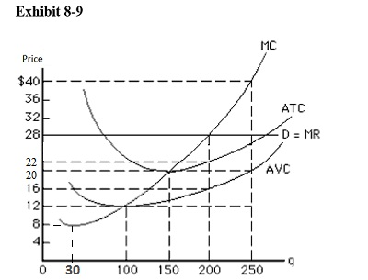
4. The firm and industry short run supply curves

If Pe = $28, Q* = ____
• If Pe = $40, Q* = _____
• If Pe = $20, Q* = _____
• If Pe = $12, Q* = _____
• If Pe = $8, Q* = _____

- The section of the MC curve above the shutdown point is _______________.

- The supply curve is a result of ___________________________.

5. Perfect competition in the long run

Case Study 5. Strawberry market
- If the firms in the industry are profitable,

Case Study 6. Watermelon market
- If the firms in the industry incur loss,

- In the short run, can firms in perfect competition earn an economic profit, break even, or lose money?

- In the long run, what is the economic profit for the firms in perfect competition market?

6. Efficiency
- Productive efficiency: occurs when the firm produces at the minimum point on its LRAC

- Allocative efficiency: Occurs when firms price the output that consumers value the most
- Demand curve is the result of utility maximization.
- It represents MB (marginal benefit/marginal utility).

- Supply curve is the result of profit maximization.
- It is the MC.

- The market reaches both productive efficiency and allocative efficiency when MB=MC.

- Consumer surplus: the difference between willingness to pay and the market price.

- Producer surplus: the difference between willingness to sell and the market price.

- Social welfare = CS + PS

- How to find social welfare?

- Equilibrium in perfect competition market maximizes social welfare

