Principles of Microeconomics

Chapter 9 Monopoly

Dr. Yuna Chen

Market Structure: Monopoly

- One seller and many buyers

- There are no close substitutes for the product

- The firm has market power; can control over price;
called price maker;
set the price at will.

- Barriers to entry
– other firms cannot enter into the market for three reasons:
legal restrictions,
economies of scale,
control of an essential resource

9-1. Barrier to entry

9-1a. Legal restrictions

Patents
Exclusive right to sell a product for 20 years from the date the patent application is filed
Reason: to protect incentive for innovation

Licenses - Government awarding an individual firm the exclusive right to supply a particular good or service
9-1b. Economies of scale

Downward-sloping long-run average cost curve - one firm can supply market demand at a lower average cost per unit than could two firms

A firm arises as a monopoly due to economies of scale is called a natural monopoly, because it is not created artificially by the government.
Economies of scale is a nature of production cost.

Ex

hibit 1

9-1c. Control of essential resources

The firm owns the resource

Examples
Alcoa (aluminum) - control the supply of bauxite | Professional sports leagues | Local monopolies – only one utility company; one movie theater…
DeBeers diamonds | China - Giant pandas  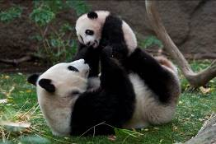 | Page 133: “Starbucks over the years has built up a unique “experience” for the customer, …”  Disagree:  1. there are many close substitutes for coffee.  2. Similar “comfortable atmosphere” can be found in other places.

9-2. Revenue for a monopolist

9-2a. Demand and marginal revenue

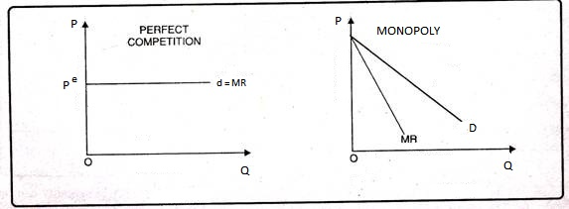

demand for a perfect competitive firm: horizontal
- For a monopolist, the firm’s demand is the market demand.
- The demand is downward-slopping: if the monopolist wants to sell more, it must lower the price.

Example1. Monopoly revenue, costs, and profits
(1) | (2) | (3) | (4) | (5) | (6) | (7) | (8)
Q | P | TR | TC | Profit | MR | MC | ATC
0 | $200 |  | 145
1 | 180 |  | 175
2 | 160 |  | 200
3 | 140 |  | 220
4 | 120 |  | 250
5 | 100 |  | 300
6 | 80 |  | 370

P
200
180
160
140
120
100
80
60
40
20
0 | 1 | 2 | 3 | 4 | 5 | 6 | 7 | Q

9-3. The monopolist’s cost and profit maximization
Golden Rule of profit maximization: MR =MC

Findings:

The demand curve is always above the MR curve in monopoly market.

This implies the monopoly price is always above MR

(P = MR in perfect competition)

- How to find the profit max. output and price?
a. MR=MC
b. Go vertically down and find the profit max output Q^{m}
c. go vertically up to the demand curve, then find P^{m}

Example 2. Short-run losses
1. What is Q^{m}?  2. What is P^{m}?  3. What is TR?  4. What is TC?  5. What is the amount of loss? | 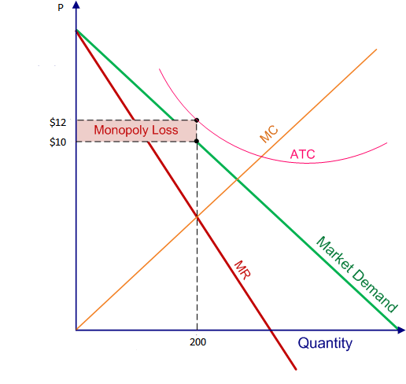

Example 3. Shutdown decision
P^{m} <AVC or FC < Loss
a. If stay in production,  economic loss =  b. If shutdown, fixed cost =  Decision: | 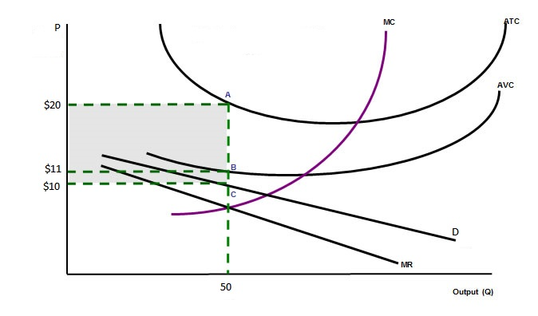
Summary:
1. If P^{m} > ATC, profitable;
if P^{m} = ATC, breaks even;
if P^{m} < ATC, suffers losses.

2. A monopoly incurs losses but should stay in production if P^{m} > AVC

3. A monopoly should shut down if P^{m} < AVC or FC < Loss

4. A monopoly can earn long run economic profit because of the barriers of entry that block competition.

5. A monopoly should exit the industry if P^{m} < ATC in the long run.
9-6. Price discrimination

Charging different groups of consumers different prices for the same product

Price discrimination increases profit

 |  | A Monopolist Price Discrimination
 | Information | Time machine travel ticket |  |  | FC | $100
 |  |  |  |  | MC | $100
 |  |  | Willing and able to pay
 |  | A | 500
 |  | B | 400
 |  | C | 380
 |  | D | 350
 |  | E | 200
 |  | F | 100
 | Potential Buyers | Q | P | TR | TC | MR | MC
 |  |  | 600
 | A |  | 500
 | B |  | 400
 | C |  | 380
 | D |  | 350
 | E |  | 200
 | F |  | 100
 | Case 1. Charge a single price (no price discrimination)
 | Case 2. Charge A and B $400 each, and C and D $350 each.
 | Case 3. Perfect price discrimination - charge each buyer a different price.

